**Observations:**

|  |
| --- |
| **Terms** |
| x = True Value |
| y = Observed Value |
| N = Total no of observation |
|  |
| **Linearity** |
| A = sqrt {sum(x^2) - (((sum(x)) ^2) / N)} |
| B = sqrt {sum(y^2) - (((sum(y)) ^2) / N)} |
| C = sum (x * y) - ((sum(x) * sum(y)) / N) |
| Linearity = C / A*B |
|  |
| **Accuracy**  % Accuracy = [ (TV - OV) * 100] / N |
| Average Accuracy = (Sum of % Accuracy)/N  **Hysteresis:**  Hysteresis = (Max of (Rising pressure – Falling pressure))/N |
|  |

**Pressure range: 1 to 9 kg/cm2**

**Set 1:**

|  |  |  |  |
| --- | --- | --- | --- |
| **True value** | **Observed value** | **Current mA** | **Voltage V** |
| 1 | 1.045 | 4.3 | 1 |
| 2 | 2.03 | 5.3 | 1.5 |
| 3 | 3.028 | 9.4 | 2 |
| 4 | 4.013 | 10.4 | 2.6 |
| 5 | 5.002 | 12.5 | 3 |
| 6 | 5.99 | 14.5 | 3.6 |
| 7 | 6.973 | 15.5 | 4 |
| 8 | 7.977 | 19.6 | 4.6 |
| 9 | 8.965 | 20.7 | 5.1 |

**Set 2:**

|  |  |  |  |
| --- | --- | --- | --- |
| **True value** | **Observed value** | **Current mA** | **Voltage V** |
| 1 | 1.05 | 4.3 | 1 |
| 2 | 2.02 | 5.3 | 1.5 |
| 3 | 3.018 | 9.4 | 2.1 |
| 4 | 4.017 | 10.5 | 2.6 |
| 5 | 4.975 | 12.4 | 3 |
| 6 | 5.98 | 14.5 | 3.5 |
| 7 | 6.968 | 15.5 | 4 |
| 8 | 7.976 | 19.6 | 4.6 |
| 9 | 8.962 | 20.7 | 5.1 |

**Set 3:**

|  |  |  |  |
| --- | --- | --- | --- |
| **True value** | **Observed value** | **Current mA** | **Voltage V** |
| 1 | 1.032 | 4.2 | 1 |
| 2 | 2.016 | 5.3 | 1.5 |
| 3 | 3.024 | 9.4 | 2.1 |
| 4 | 4.007 | 10.4 | 2.6 |
| 5 | 4.99 | 12.5 | 3.1 |
| 6 | 5.985 | 14.5 | 3.6 |
| 7 | 6.947 | 15.5 | 4 |
| 8 | 7.969 | 19.6 | 4.6 |
| 9 | 8.955 | 20.6 | 5 |

**Linearity** = 0.9999986065

**Average Accuracy** = 0.3185185185

**Rising pressure:**

|  |  |  |  |
| --- | --- | --- | --- |
| **True value** | **Observed value** | **Current mA** | **Voltage V** |
| 0 | 0.01 | 2.1 | 0.5 |
| 1 | 1.025 | 4.2 | 1 |
| 2 | 2.024 | 5.3 | 1.5 |
| 3 | 3.025 | 9.4 | 2 |
| 4 | 4.015 | 10.4 | 2.6 |
| 5 | 5 | 12.5 | 3 |
| 6 | 5.98 | 14.5 | 3.6 |
| 7 | 6.96 | 15.5 | 4 |
| 8 | 7.96 | 19.6 | 4.6 |
| 9 | 8.94 | 20.6 | 5.1 |

**Falling pressure:**

|  |  |  |  |
| --- | --- | --- | --- |
| **True value** | **Observed value** | **Current mA** | **Voltage V** |
| 0 | 0.005 | 2.1 | 0.5 |
| 1 | 1.004 | 4.2 | 1 |
| 2 | 1.975 | 5.2 | 1.5 |
| 3 | 2.975 | 9.3 | 2 |
| 4 | 3.981 | 10.3 | 2.5 |
| 5 | 4.951 | 12.4 | 3 |
| 6 | 5.94 | 14.4 | 3.6 |
| 7 | 6.955 | 15.5 | 4 |
| 8 | 7.953 | 19.6 | 4.6 |
| 9 | 8.94 | 20.6 | 5.1 |

**Hysteresis** =0.05

**Pressure range: 4 to 6 kg/cm2**

**Set 1:**

|  |  |  |  |
| --- | --- | --- | --- |
| **True value** | **Observed value** | **Current mA** | **Voltage V** |
| 4 | 4.02 | 4.2 | 1 |
| 4.2 | 4.182 | 5.7 | 1.4 |
| 4.4 | 4.382 | 7.3 | 1.8 |
| 4.6 | 4.58 | 9 | 2.2 |
| 4.8 | 4.785 | 10.7 | 2.6 |
| 5 | 4.983 | 12.3 | 3 |
| 5.2 | 5.173 | 13.9 | 3.4 |
| 5.4 | 5.351 | 15.4 | 3.8 |
| 5.6 | 5.532 | 15.8 | 4.1 |
| 5.8 | 5.778 | 19.8 | 4.6 |
| 6 | 5.977 | 20.6 | 5 |

**Set 2:**

|  |  |  |  |
| --- | --- | --- | --- |
| **True value** | **Observed value** | **Current mA** | **Voltage V** |
| 4 | 4.001 | 4.2 | 1 |
| 4.2 | 4.175 | 5.6 | 1.4 |
| 4.4 | 4.355 | 7.1 | 1.7 |
| 4.6 | 4.574 | 9.9 | 2.2 |
| 4.8 | 4.77 | 10.5 | 2.6 |
| 5 | 4.992 | 12.4 | 3 |
| 5.2 | 5.185 | 14 | 3.4 |
| 5.4 | 5.352 | 15.4 | 3.8 |
| 5.6 | 5.556 | 17 | 4.2 |
| 5.8 | 5.762 | 19.8 | 4.6 |
| 6 | 5.97 | 20.5 | 5 |

**Set 3:**

|  |  |  |  |
| --- | --- | --- | --- |
| **True value** | **Observed value** | **Current mA** | **Voltage V** |
| 4 | 3.99 | 4.1 | 1 |
| 4.2 | 4.177 | 5.6 | 1.4 |
| 4.4 | 4.39 | 7.2 | 1.8 |
| 4.6 | 4.59 | 9.1 | 2.2 |
| 4.8 | 4.785 | 10.7 | 2.6 |
| 5 | 4.985 | 12.3 | 3 |
| 5.2 | 5.167 | 13.8 | 3.4 |
| 5.4 | 5.355 | 15.4 | 3.8 |
| 5.6 | 5.555 | 17 | 4.2 |
| 5.8 | 5.751 | 19.7 | 4.6 |
| 6 | 5.975 | 20.6 | 5 |

**Linearity =** 0.9996595982

**Average Accuracy =** 2.560606061

**Hysteresis:**

**Rising Pressure:**

|  |  |  |  |
| --- | --- | --- | --- |
| **True value** | **Observed value** | **Current mA** | **Voltage V** |
| 4 | 3.99 | 4.1 | 1 |
| 4.2 | 4.191 | 5.8 | 1.4 |
| 4.4 | 4.366 | 7.2 | 1.8 |
| 4.6 | 4.585 | 9 | 2.2 |
| 4.8 | 4.777 | 10.6 | 2.6 |
| 5 | 4.988 | 12.4 | 3 |
| 5.2 | 5.175 | 13.9 | 3.4 |
| 5.4 | 5.37 | 15.5 | 3.8 |
| 5.6 | 5.55 | 17 | 4.2 |
| 5.8 | 5.771 | 19.8 | 4.6 |
| 6 | 5.945 | 20.3 | 5 |

**Falling Pressure:**

|  |  |  |  |
| --- | --- | --- | --- |
| **True value** | **Observed value** | **Current mA** | **Voltage V** |
| 4 | 3.972 | 4 | 1 |
| 4.2 | 4.167 | 5.6 | 1.4 |
| 4.4 | 4.35 | 7.1 | 1.7 |
| 4.6 | 4.555 | 9.8 | 2.2 |
| 4.8 | 4.742 | 10.4 | 2.5 |
| 5 | 4.976 | 12.2 | 3 |
| 5.2 | 5.144 | 13.7 | 3.4 |
| 5.4 | 5.332 | 15.2 | 3.8 |
| 5.6 | 5.52 | 15.7 | 4.2 |
| 5.8 | 5.733 | 19.6 | 4.6 |
| 6 | 5.945 | 20.3 | 5 |

**Hysteresis =** 0.038

**Pressure range: 6 - 9 kg/cm2**

**Set 1:**

|  |  |  |  |
| --- | --- | --- | --- |
| **True value** | **Observed value** | **Current mA** | **Voltage V** |
| 6 | 5.995 | 4 | 1 |
| 6.2 | 6.18 | 4.9 | 1.27 |
| 6.4 | 6.385 | 5.1 | 1.54 |
| 6.6 | 6.555 | 7 | 1.77 |
| 6.8 | 6.765 | 9.1 | 2.06 |
| 7 | 6.971 | 9.2 | 2.35 |
| 7.2 | 7.174 | 10.3 | 2.52 |
| 7.4 | 7.372 | 11.4 | 2.99 |
| 7.6 | 7.575 | 12.4 | 3.17 |
| 7.8 | 7.77 | 13.5 | 3.43 |
| 8 | 7.972 | 14.5 | 3.71 |
| 8.2 | 8.172 | 15.6 | 3.98 |
| 8.4 | 8.385 | 15.7 | 4.27 |
| 8.6 | 8.586 | 17.8 | 4.54 |
| 8.8 | 8.765 | 19.7 | 4.79 |
| 9 | 8.975 | 20 | 5.08 |

**Set 2:**

|  |  |  |  |
| --- | --- | --- | --- |
| **True value** | **Observed value** | **Current mA** | **Voltage V** |
| 6 | 5.976 | 4 | 1 |
| 6.2 | 6.174 | 5 | 1.26 |
| 6.4 | 6.381 | 5 | 1.54 |
| 6.6 | 6.575 | 7.1 | 1.91 |
| 6.8 | 6.767 | 9.1 | 2.07 |
| 7 | 6.982 | 9.2 | 2.36 |
| 7.2 | 7.19 | 10.4 | 2.55 |
| 7.4 | 7.385 | 11.4 | 2.91 |
| 7.6 | 7.58 | 12.4 | 3.17 |
| 7.8 | 7.779 | 13.5 | 3.44 |
| 8 | 7.992 | 14.6 | 3.74 |
| 8.2 | 8.175 | 15.6 | 3.99 |
| 8.4 | 8.39 | 15.8 | 4.28 |
| 8.6 | 8.59 | 17.8 | 4.55 |
| 8.8 | 8.794 | 19.9 | 4.93 |
| 9 | 8.99 | 20 | 5.09 |

**Set 3:**

|  |  |  |  |
| --- | --- | --- | --- |
| **True value** | **Observed value** | **Current mA** | **Voltage V** |
| 6 | 6 | 4 | 1 |
| 6.2 | 6.179 | 5 | 1.27 |
| 6.4 | 6.385 | 5.1 | 1.55 |
| 6.6 | 6.57 | 7 | 1.9 |
| 6.8 | 6.774 | 9.2 | 2.08 |
| 7 | 6.985 | 9.3 | 2.37 |
| 7.2 | 7.19 | 10.4 | 2.54 |
| 7.4 | 7.39 | 11.4 | 2.92 |
| 7.6 | 7.565 | 12.4 | 3.16 |
| 7.8 | 7.78 | 13.5 | 3.45 |
| 8 | 7.98 | 14.6 | 3.72 |
| 8.2 | 8.189 | 15.7 | 4 |
| 8.4 | 8.396 | 15.8 | 4.28 |
| 8.6 | 8.57 | 17.8 | 4.53 |
| 8.8 | 8.77 | 19.8 | 4.79 |
| 9 | 8.96 | 19.8 | 5.95 |

**Linearity =** 0.9999791595

**Average Accuracy** = 2.114583333

**Hysteresis:**

**Rising pressure:**

|  |  |  |  |
| --- | --- | --- | --- |
| **True value** | **Observed value** | **Current mA** | **Voltage V** |
| 6 | 5.975 | 3.9 | 0.99 |
| 6.2 | 6.184 | 5 | 1.27 |
| 6.4 | 6.384 | 5.1 | 1.54 |
| 6.6 | 6.562 | 7 | 1.79 |
| 6.8 | 6.78 | 9.2 | 2.08 |
| 7 | 6.98 | 9.3 | 2.35 |
| 7.2 | 7.193 | 10.4 | 2.55 |
| 7.4 | 7.383 | 11.4 | 2.9 |
| 7.6 | 7.583 | 12.5 | 3.18 |
| 7.8 | 7.775 | 13.5 | 3.44 |
| 8 | 7.988 | 14.6 | 3.74 |
| 8.2 | 8.17 | 15.6 | 3.98 |
| 8.4 | 8.383 | 15.7 | 4.27 |
| 8.6 | 8.57 | 17.7 | 4.52 |
| 8.8 | 8.779 | 19.8 | 4.91 |
| 9 | 8.969 | 19.9 | 5.06 |

**Falling pressure:**

|  |  |  |  |
| --- | --- | --- | --- |
| **True value** | **Observed value** | **Current mA** | **Voltage V** |
| 6 | 5.56 | 3.8 | 0.97 |
| 6.2 | 6.155 | 4.8 | 1.23 |
| 6.4 | 6.356 | 5.9 | 1.5 |
| 6.6 | 6.566 | 7 | 1.9 |
| 6.8 | 6.75 | 9 | 2.04 |
| 7 | 6.958 | 9.1 | 2.33 |
| 7.2 | 7.165 | 10.3 | 2.51 |
| 7.4 | 7.36 | 11.3 | 2.98 |
| 7.6 | 7.559 | 12.3 | 3.15 |
| 7.8 | 7.74 | 13.3 | 3.41 |
| 8 | 7.95 | 14.4 | 3.58 |
| 8.2 | 8.16 | 15.5 | 3.96 |
| 8.4 | 8.375 | 15.7 | 4.26 |
| 8.6 | 8.573 | 17.7 | 4.53 |
| 8.8 | 8.754 | 19.7 | 4.77 |
| 9 | 8.969 | 19.9 | 5.06 |

**Hysteresis** = 0.04425

**Pressure range: 1 - 4 kg/cm2**

**Set 1:**

|  |  |  |  |
| --- | --- | --- | --- |
| **True value** | **Observed value** | **Current mA** | **Voltage V** |
| 1 | 1.01 | 4.1 | 1.04 |
| 1.2 | 1.242 | 5.3 | 1.36 |
| 1.4 | 1.442 | 5.4 | 1.53 |
| 1.6 | 1.62 | 7.3 | 1.97 |
| 1.8 | 1.812 | 9.3 | 2.13 |
| 2 | 2.04 | 9.5 | 2.44 |
| 2.2 | 2.194 | 10.4 | 2.54 |
| 2.4 | 2.44 | 11.7 | 2.99 |
| 2.6 | 2.607 | 12.6 | 3.21 |
| 2.8 | 2.816 | 13.7 | 3.49 |
| 3 | 3.02 | 14.8 | 3.78 |
| 3.2 | 3.215 | 15.8 | 4.04 |
| 3.4 | 3.426 | 17 | 4.33 |
| 3.6 | 3.635 | 19.1 | 4.51 |
| 3.8 | 3.825 | 19.1 | 4.97 |
| 4 | 4.022 | 20.1 | 5.14 |

**Set 2:**

|  |  |  |  |
| --- | --- | --- | --- |
| **True value** | **Observed value** | **Current mA** | **Voltage V** |
| 1 | 1.031 | 4.2 | 1.06 |
| 1.2 | 1.26 | 5.4 | 1.38 |
| 1.4 | 1.442 | 5.4 | 1.53 |
| 1.6 | 1.655 | 7.6 | 1.91 |
| 1.8 | 1.826 | 9.4 | 2.14 |
| 2 | 2.035 | 9.5 | 2.44 |
| 2.2 | 2.22 | 10.5 | 2.58 |
| 2.4 | 2.455 | 11.8 | 3 |
| 2.6 | 2.61 | 12.6 | 3.22 |
| 2.8 | 2.84 | 13.8 | 3.53 |
| 3 | 3.026 | 14.8 | 3.79 |
| 3.2 | 3.192 | 15.7 | 4.01 |
| 3.4 | 3.432 | 17 | 4.34 |
| 3.6 | 3.6 | 17.9 | 4.36 |
| 3.8 | 3.83 | 19.1 | 4.98 |
| 4 | 4.018 | 20.1 | 5.14 |

**Set 3:**

|  |  |  |  |
| --- | --- | --- | --- |
| **True value** | **Observed value** | **Current mA** | **Voltage V** |
| 1 | 1.015 | 4.1 | 1.04 |
| 1.2 | 1.25 | 5.4 | 1.37 |
| 1.4 | 1.422 | 5.3 | 1.51 |
| 1.6 | 1.656 | 7.5 | 1.92 |
| 1.8 | 1.839 | 9.5 | 2.17 |
| 2 | 2.026 | 9.5 | 2.42 |
| 2.2 | 2.24 | 10.6 | 2.71 |
| 2.4 | 2.458 | 11.8 | 3.01 |
| 2.6 | 2.645 | 12.8 | 3.26 |
| 2.8 | 2.83 | 13.7 | 3.52 |
| 3 | 3.036 | 14.9 | 3.9 |
| 3.2 | 3.234 | 15.9 | 4.07 |
| 3.4 | 3.446 | 17.1 | 4.35 |
| 3.6 | 3.636 | 19.1 | 4.51 |
| 3.8 | 3.826 | 19.1 | 4.98 |
| 4 | 4.017 | 20.1 | 5.13 |

**Linearity** = 0.9999387879

**Average Accuracy** = 2.945833333

**Hysteresis:**

**Rising pressure:**

|  |  |  |  |
| --- | --- | --- | --- |
| **True value** | **Observed value** | **Current mA** | **Voltage V** |
| 1 | 1.03 | 4.2 | 1.07 |
| 1.2 | 1.26 | 5.4 | 1.38 |
| 1.4 | 1.448 | 5.4 | 2.54 |
| 1.6 | 1.652 | 7.5 | 1.91 |
| 1.8 | 1.822 | 8.5 | 2.14 |
| 2 | 2.044 | 9.6 | 2.44 |
| 2.2 | 2.236 | 10.6 | 2.71 |
| 2.4 | 2.453 | 11.8 | 3 |
| 2.6 | 2.642 | 12.8 | 3.36 |
| 2.8 | 2.842 | 13.8 | 3.53 |
| 3 | 3.035 | 15 | 3.9 |
| 3.2 | 3.233 | 15.9 | 4.06 |
| 3.4 | 3.44 | 17 | 4.34 |
| 3.6 | 3.63 | 18 | 4.51 |
| 3.8 | 3.82 | 19.1 | 4.96 |
| 4 | 4.027 | 20.1 | 5.15 |

**Falling pressure:**

|  |  |  |  |
| --- | --- | --- | --- |
| **True value** | **Observed value** | **Current mA** | **Voltage V** |
| 1 | 1.02 | 4.1 | 1.05 |
| 1.2 | 1.995 | 5.1 | 1.3 |
| 1.4 | 1.415 | 5.2 | 1.59 |
| 1.6 | 1.614 | 7.3 | 1.96 |
| 1.8 | 1.806 | 9.3 | 2.12 |
| 2 | 2.006 | 9.4 | 2.39 |
| 2.2 | 2.196 | 10.4 | 2.54 |
| 2.4 | 2.4 | 11.6 | 2.94 |
| 2.6 | 2.597 | 12.5 | 3.2 |
| 2.8 | 2.81 | 13.7 | 3.48 |
| 3 | 3.02 | 14.8 | 3.77 |
| 3.2 | 3.179 | 15.6 | 3.98 |
| 3.4 | 3.381 | 15.7 | 4.26 |
| 3.6 | 3.583 | 18 | 4.53 |
| 3.8 | 3.815 | 19 | 4.95 |
| 4 | 4.027 | 20.1 | 5.15 |

**Hysteresis** = 0.015625

|  |  |  |  |
| --- | --- | --- | --- |
| **Pressure range (kg/cm^2)** | **Average Accuracy**  **(%)** | **Linearity**  **(% of full scale)** | **Hysteresis** |
| 1 to 9 | *0.035* | *0.999* | 0.05 |
| 4 to 6 | *0.233* | *0.999* | *0.038* |
| 6 to 9 | *0.132* | *0.999* | 0.415 |
| 1 to 4 | 0.184 | 0.999 | 0.059 |

**True vs Observed pressure:**

**Range: 1 to 9 kg/cm2 :**

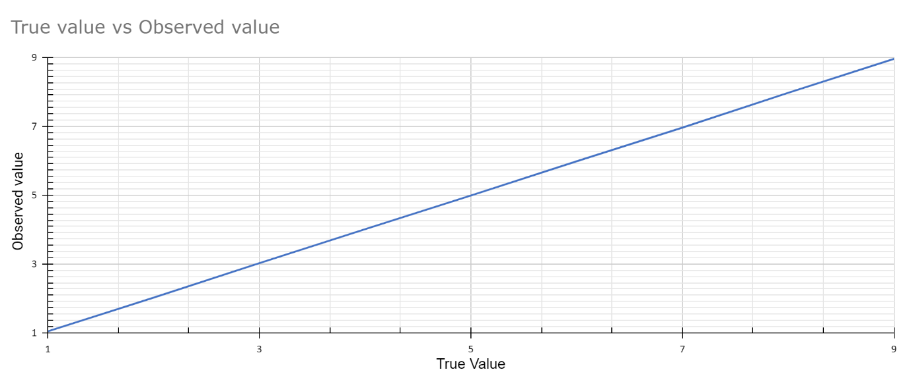

**Range: 4 to 6 kg/cm2 :**

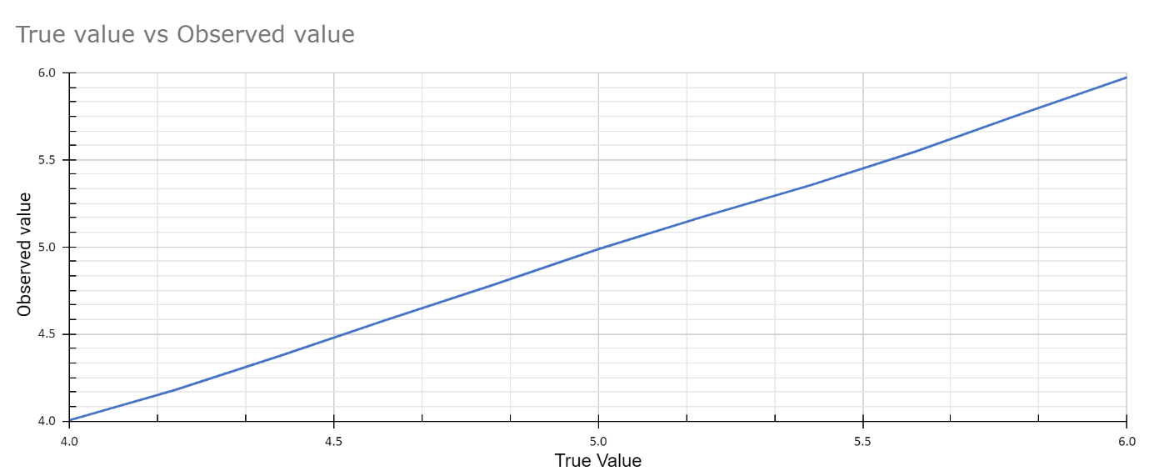

**Range: 6 to 9 kg/cm2 :**

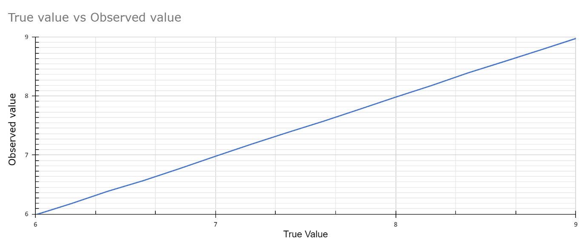

**Range: 1 to 4 kg/cm2 :**

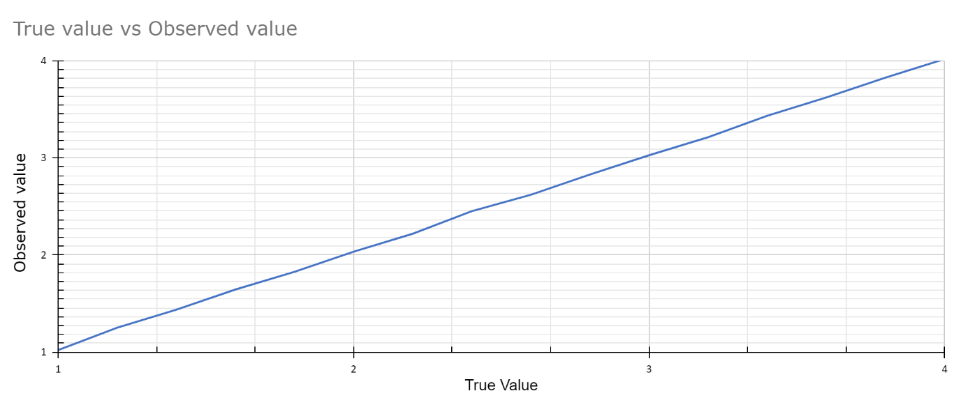

**Hysteresis graph :**

**Range: 1 to 9 kg/cm2 :**

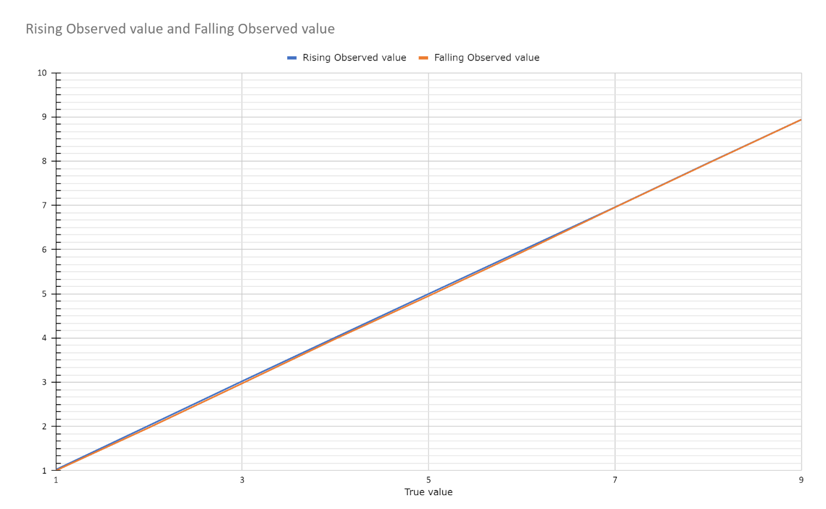

**Range: 4 to 6 kg/cm2 :**

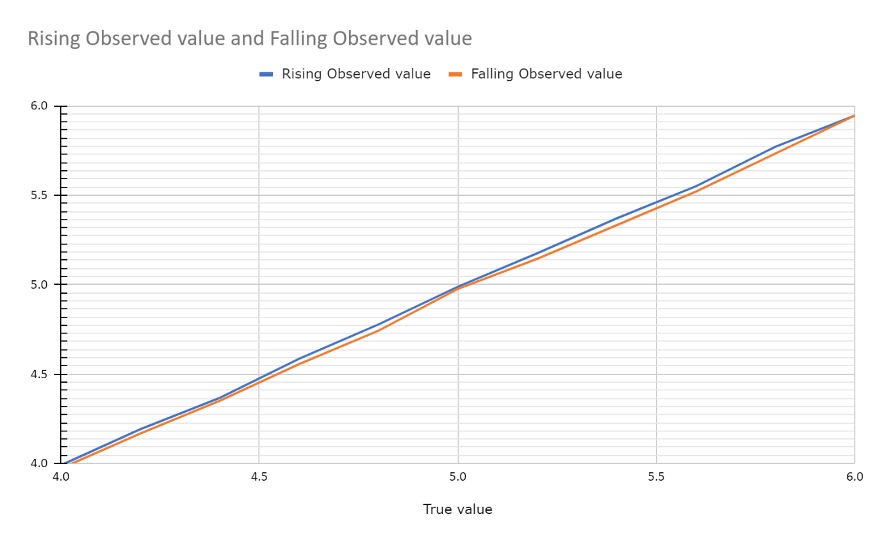

**Range: 6 to 9 kg/cm2 :**

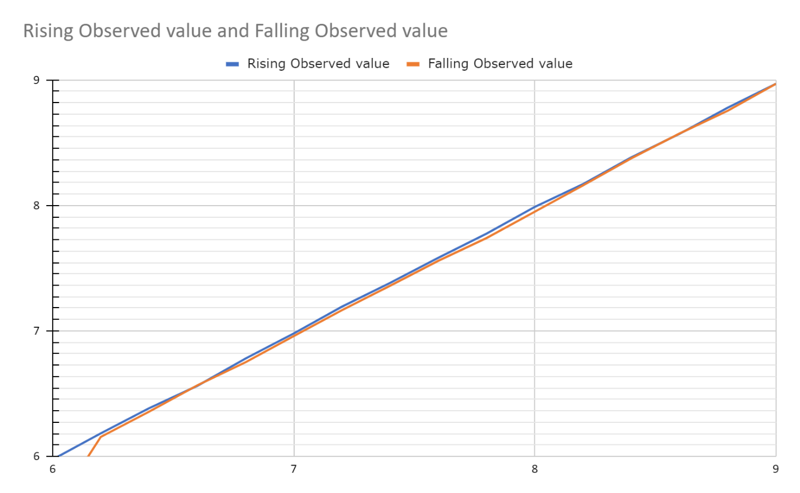

**Range: 1 to 4 kg/cm2 :**

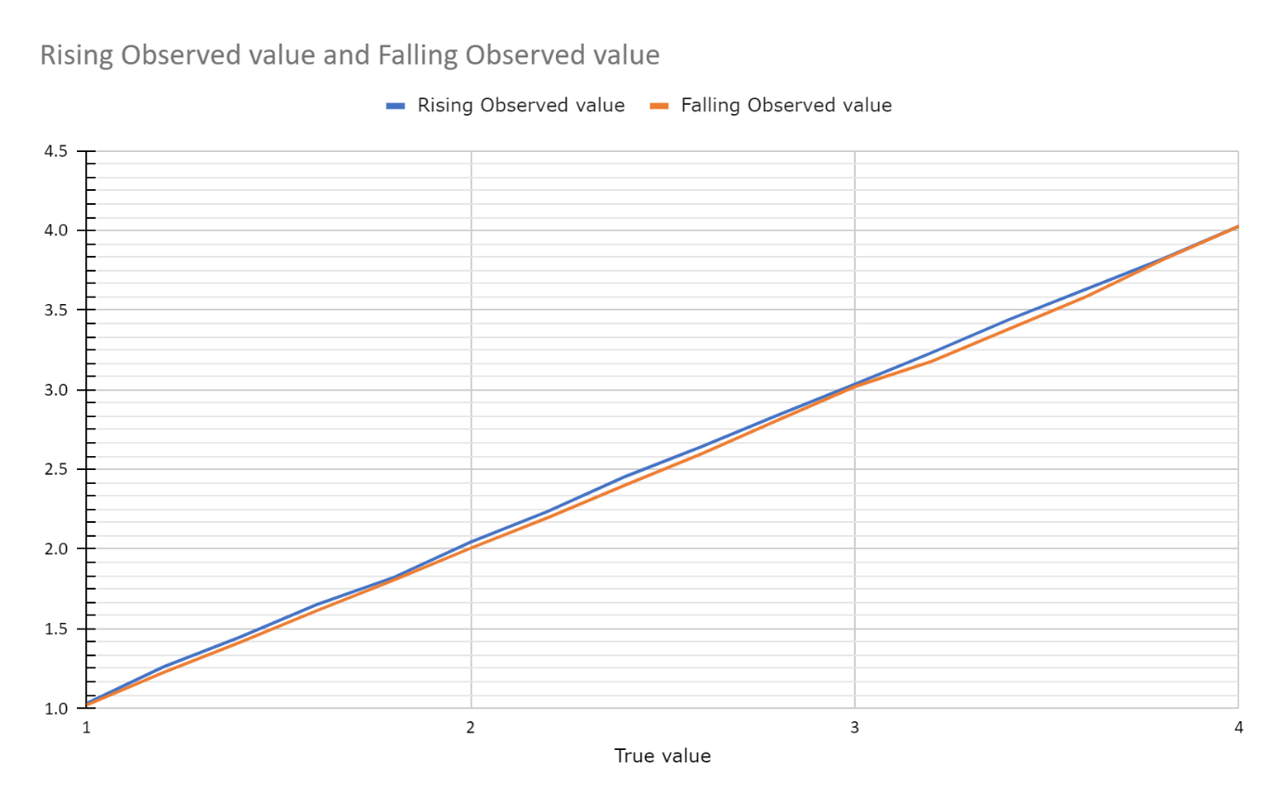

**Pressure range: 1 to 9 kg/cm2:**

* Set value 5 kg/cm2
* Data points: 4849
* Training set: 3000
* Testing set: 1849
* Mean: 5.045
* Variance: 0.00018
* SD: 0.0137

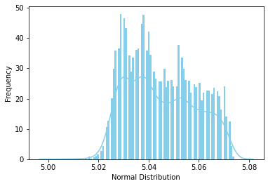

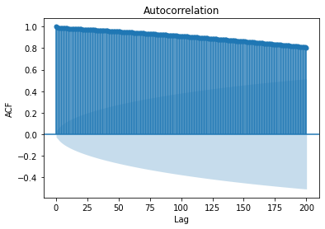

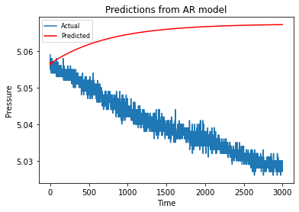

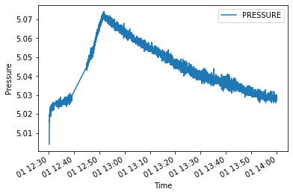

**Pressure range: 1 to 4 kg/cm2**

* Set value 2 kg/cm2
* Data points: 3600
* Training set: 2000
* Testing set: 1600
* Mean: 2.0022
* Variance: 0.0004
* SD: 0.02036

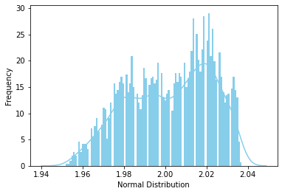

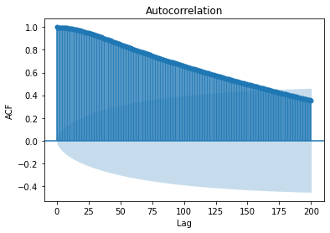

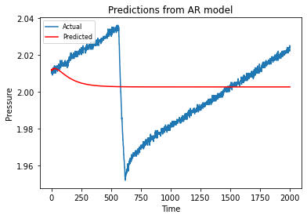

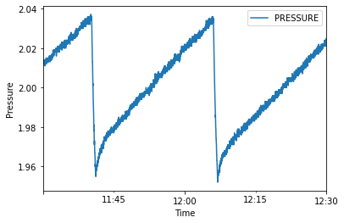

**Pressure range: 6 to 9 kg/cm2**

* Set value 7 kg/cm2
* Data points: 2367
* Training set: 1500
* Testing set: 867
* Mean: 6.9933
* Variance: 0.0015
* SD: 0.03835

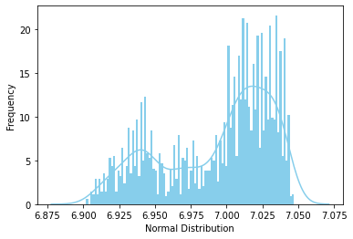

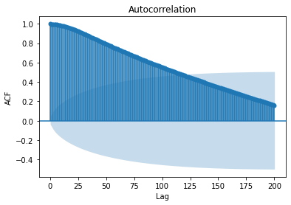

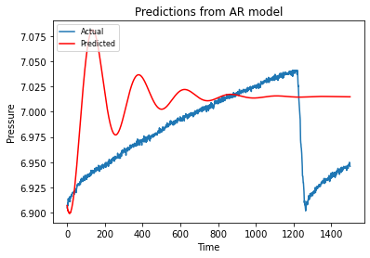

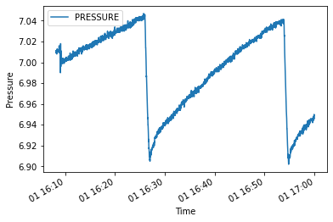

**Pressure range: 4 to 6 kg/cm2**

* Set value 5 kg/cm2
* Data points: 2744
* Training set: 1500
* Testing set: 1244
* Mean: 4.9965
* Variance: 0.00093
* SD: 0.03052

